Case Study – Questions
Use the data in the excel workbook video_games_data to attempt the below questions.

a) Find day 1, day 3 and day 7 retention.
SELECT 'Day 1' AS Day, COUNT(DISTINCT user_id) AS Retained_Users
FROM event_log
WHERE DATEDIFF(DATE(logtime), DATE('2020-03-01')) = 1
UNION ALL
SELECT 'Day 3', COUNT(DISTINCT user_id)
FROM event_log
WHERE DATEDIFF(DATE(logtime), DATE('2020-03-01')) = 3
UNION ALL
SELECT 'Day 7', COUNT(DISTINCT user_id)
FROM event_log
WHERE DATEDIFF(DATE(logtime), DATE('2020-03-01')) = 7;

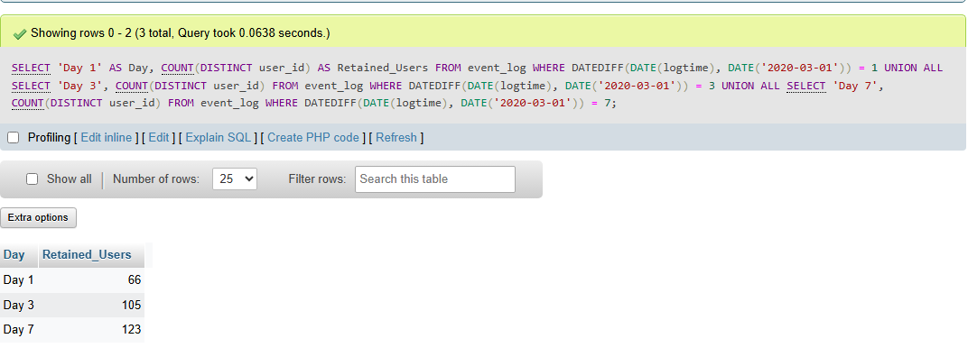

b) Find the number of video games released each year. Which year had the highest number of releases?
SELECT Year, COUNT(*) AS number_of_releases
FROM sales
WHERE Year IS NOT NULL
GROUP BY Year
ORDER BY number_of_releases DESC
LIMIT 1;
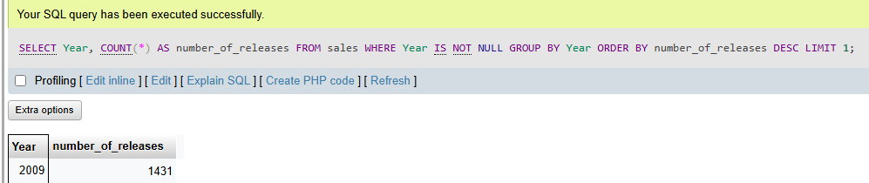
SELECT Year, COUNT(*) AS number_of_releases
FROM sales
WHERE Year IS NOT NULL
GROUP BY Year
ORDER BY Year;
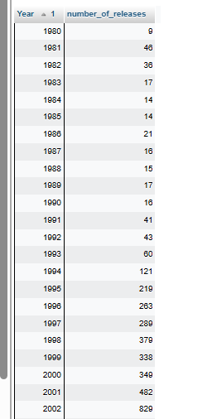

c) Which genre had the lowest global sales in the year 2010?
SELECT v.Genre, SUM(s.Global_Sales) AS total_global_sales
FROM sales s
JOIN game_details v ON s.Name = v.Name
WHERE s.Year = 2010
GROUP BY v.Genre
ORDER BY total_global_sales
LIMIT 1;
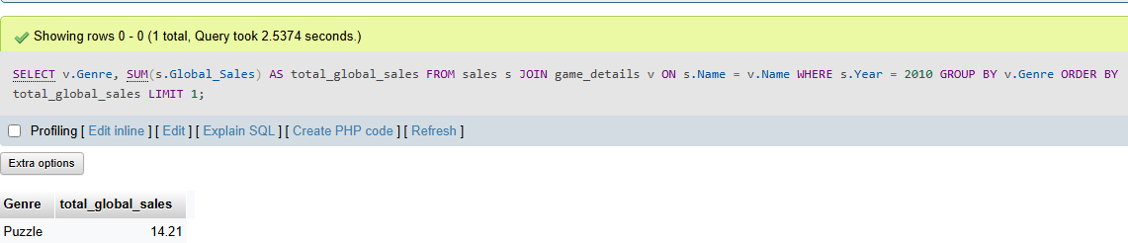
d) Find the top 10 publishers in terms of global sales. How much was their total contribution to global sales?
SELECT v.Genre, SUM(s.Global_Sales) AS total_global_sales
FROM users s
JOIN Video_games v ON s.Name = v.Name
JOIN top_publishers t ON v.Publisher = t.Publisher
GROUP BY v.Genre
ORDER BY total_global_sales DESC;

e) Which genre garnered the highest sales from the top 10 publishers? How much was the contribution of the sales from these genres to the total sales by each genre?
WITH top_publishers AS
(SELECT v.Publisher
FROM users s
JOIN Video_games v ON s.Name = v.Name
GROUP BY v.Publisher
ORDER BY SUM(s.Global_Sales) DESC
LIMIT 10)
f) Calculate the lifetime revenue generated from the sales of video games in North America and Japan separately for each year

SELECT v.Genre, SUM(s.Global_Sales) AS total_global_sales
FROM users s
JOIN Video_games v ON s.Name = v.Name
JOIN top_publishers t ON v.Publisher = t.Publisher
GROUP BY v.Genre
ORDER BY total_global_sales DESC;

